HANDS-ON: 1 - ASP.NET Core Web API – Creating Your First Web API
Aim:
To create a simple ASP.NET Core Web API application and understand the concepts of RESTful Web Services, Web API, Microservices, HTTP Request/Response, HTTP Action Verbs, HTTP Status Codes, and Web API configuration files.
Theory
RESTful Web Service: REST (Representational State Transfer) is an architectural style used to develop web services using HTTP. It usually exchanges data in JSON format.
Features of REST:
- Stateless
- Uses HTTP methods
- Resource-based URLs
- Supports JSON/XML
- Lightweight and scalable
Web API: A Web API allows applications to communicate over HTTP and exchange data, usually in JSON format.
Microservice: A Microservice is a small, independent service that performs a specific business function.
Difference between Web Service and Web API
Web Service | Web API
Uses SOAP/XML | Uses REST/HTTP
Mostly XML | JSON or XML
More complex | Lightweight

HTTP Request: A request sent by the client to the server to access or modify data.
HTTP Response: The response sent by the server containing data and a status code.
HTTP Action Verbs:
Action Verb | Description
GET | Retrieve data
POST | Create new data
PUT | Update existing data
DELETE | Delete existing data

HTTP Status Codes:
Status Code | Description
200 OK | Success
400 Bad Request | Invalid request
401 Unauthorized | Authentication required
500 Internal Server Error | Server error

Structure of Web API:
Controller – Handles requests.
Action Methods – Execute operations using HTTP verbs.
Program.cs – Configures services and middleware.
Configuration Files:
Program.cs – Configures the application and services.
appsettings.json – Stores application settings.
launchSettings.json – Stores launch and environment settings.

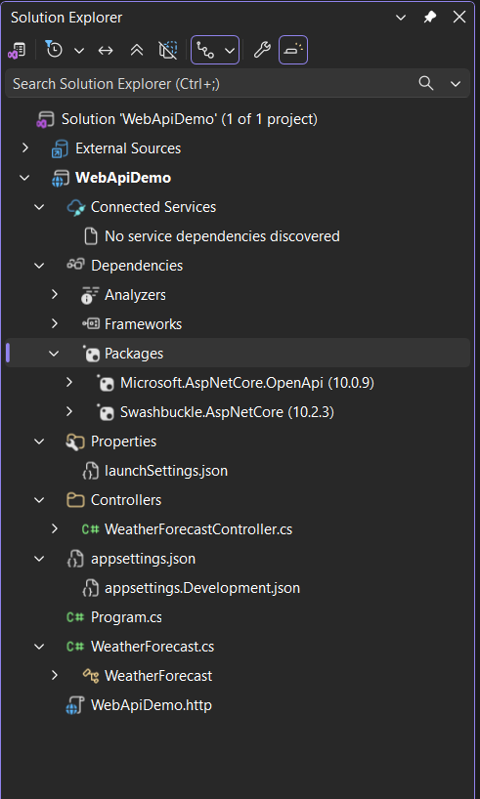
Procedure
- Open Visual Studio.
- Select Create a New Project.
- Choose ASP.NET Core Web API.
- Enter Project Name: WebApiDemo.
- Select .NET 10.0 LTS.
- Enable:
- Use Controllers
- Configure for HTTPS
- OpenAPI Support
- Click Create.
- Run the application.
- Execute the following endpoint:
- https://localhost:7013/weatherforecast
- Verify that JSON data is returned successfully.

Output
The application returned the following JSON response:
[{
"date": "2026-07-22",
"temperatureC": 54,
"temperatureF": 129,
"summary": "Freezing"
},{
"date": "2026-07-23",
"temperatureC": 29,
"temperatureF": 84,
"summary": "Sweltering"
},{
"date": "2026-07-24",
"temperatureC": 4,
"temperatureF": 39,
"summary": "Sweltering"
},{
"date": "2026-07-25",
"temperatureC": 49,
"temperatureF": 120,
"summary": "Scorching"
},{
"date": "2026-07-26",
"temperatureC": -3,
"temperatureF": 27,
"summary": "Bracing"
}]

